Skeletal muscles, tendons, and joints work together like levers to move bones. A lever is a simple machine. The three classes of levers are illustrated below:
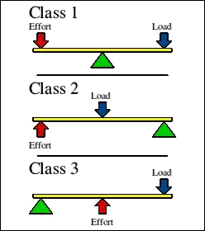
- Use the following website: http://www.robotee.com/index.php/robotic-mechanisms-levers-51008/
Watch the video “What is a Lever” on the top of the page and define the terms:
- Fulcrum

- Effort

- Load

- Further down on the webpage, it will give you examples of biomechanics and levers. For each class of lever, identify and (simply) sketch the bones/muscles that act like that lever.
- Class 1 Lever:

- Class 2 Lever:

- Class 3 Lever:

